**TITLE OF ASSIGNMENT:** Programming 282- Assignment (Milestone 1)

BY

Armandré Erasmus (577311)

Hrudhay Reddy Garisa (577833)

Phogole Amos Dampe Mamogobo (577527)

Triakshan Reddy (577449)

**TOPIC:** Databases and their Applications in C#

Submitted to Belgium Campus Regarding the Module of Programming (PRG282)

Bachelor of Computing (Year 2)

**LECTURER:** Ms. J. Blignaut

**SUBMISSION DATE:** 07 November 2023

Contents

1. Presentation Layer: 3

1.1. Login Form: 3

1.2. Student Form: 3

1.3. Module Form: 4

2. Business Logic Layer: 4

3. Data Layer: 5

# Presentation Layer:

## Login Form:

The first form is the login page which is used to validate usernames and passwords. If the data is invalid, an error is thrown, and the user has another attempt. if a user exists on the text file, they are navigated to the student page as a current user. If data is valid but does not exist, the user is added to the system’s text file and navigated to the student page. Here is a template created by us which demonstrates the login form:

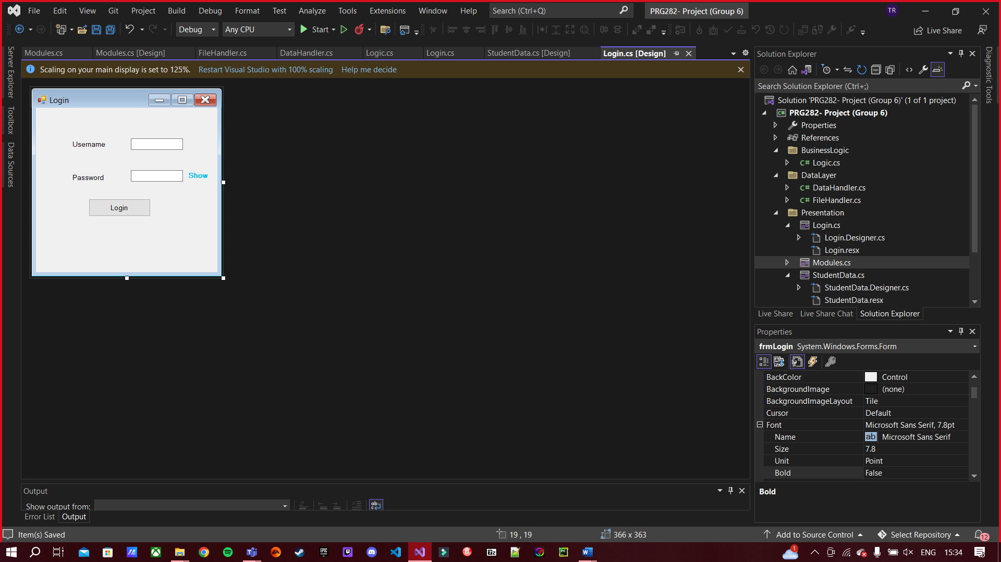

## Student Form:

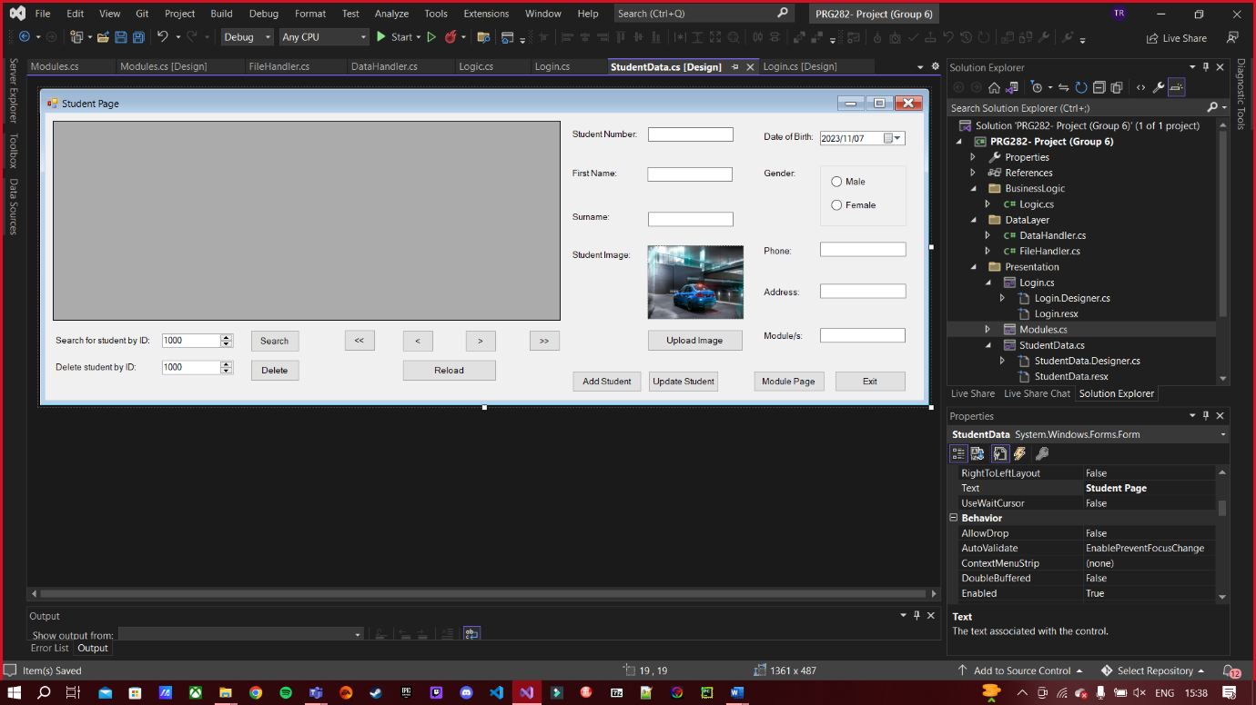This form is used to perform CRUD operations on the student table in our database. It contains a DataGridView component which displays all fields of the student table, as well as input controls for entering the relevant data into the database. It is also possible for users to navigate to the modules form. Here is a template of the student page:

## Module Form:

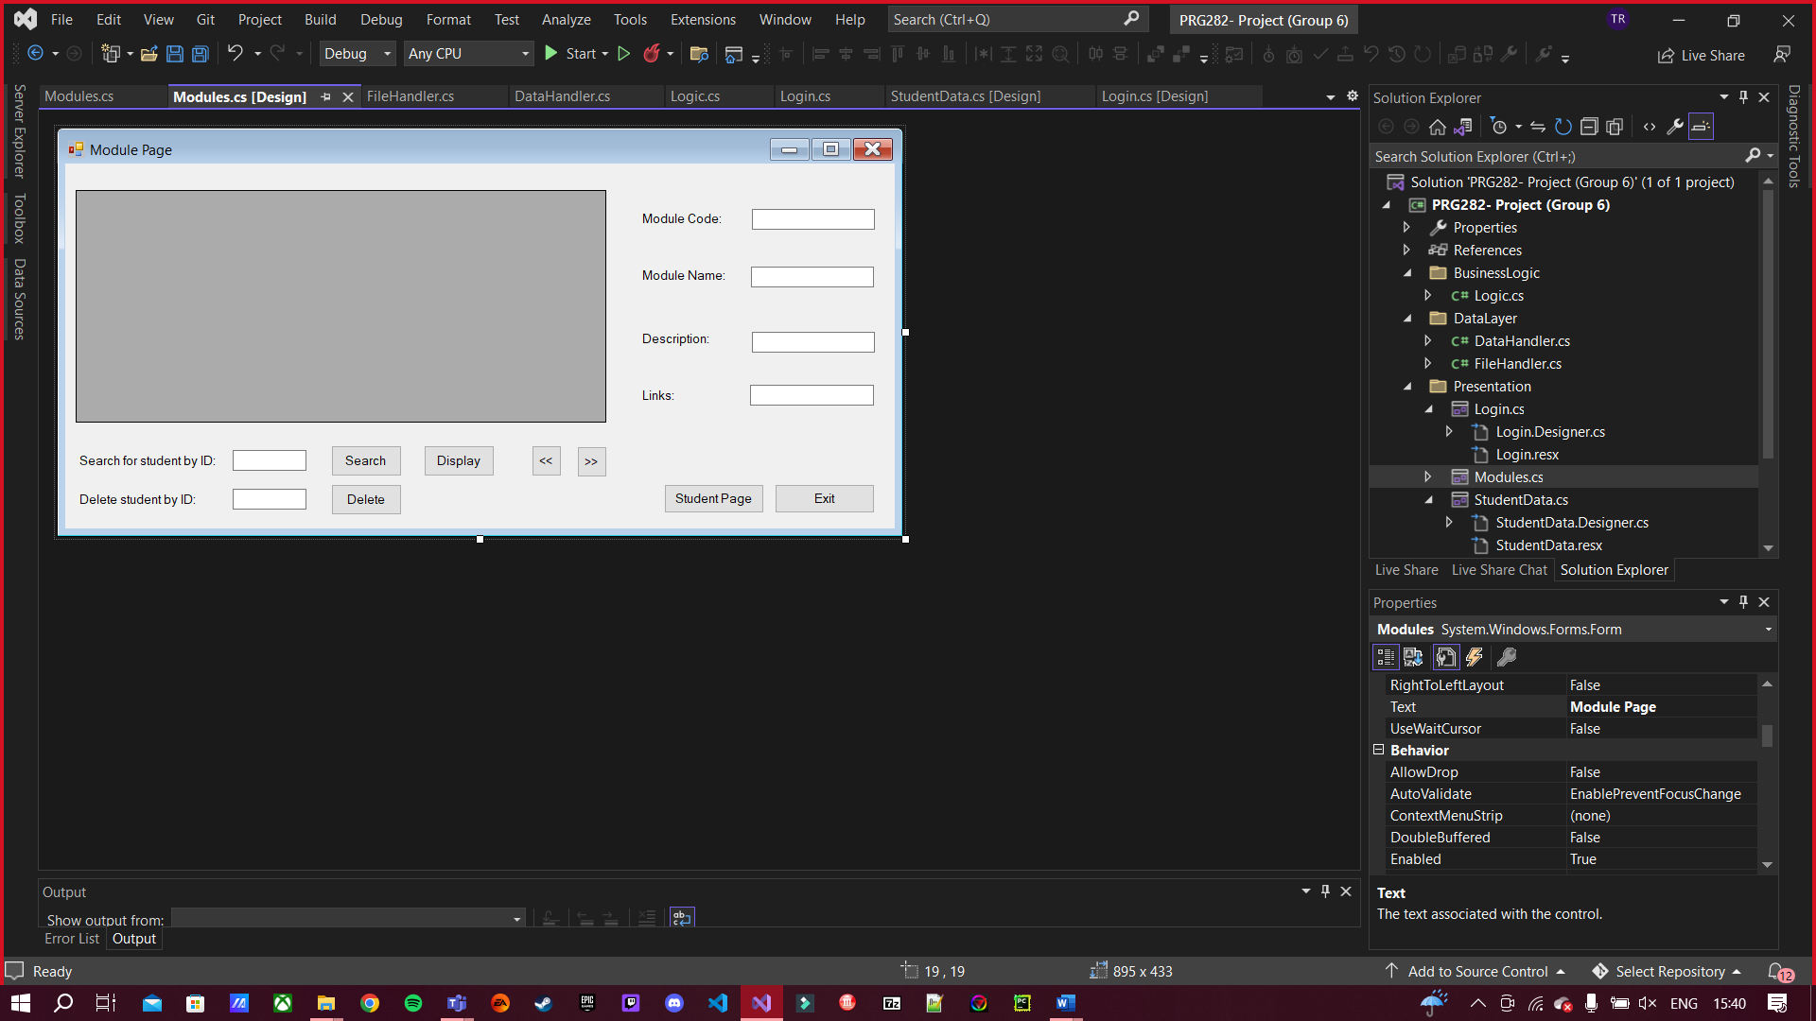The module form is used to implement the CRUD operations on the module table of the database. Specifically, users can create new modules on this page unlike the student page, in which modules can only be entered as one field in the student table. These modules are then added as options for students. Here is a template of the module form of our project:

# Business Logic Layer:

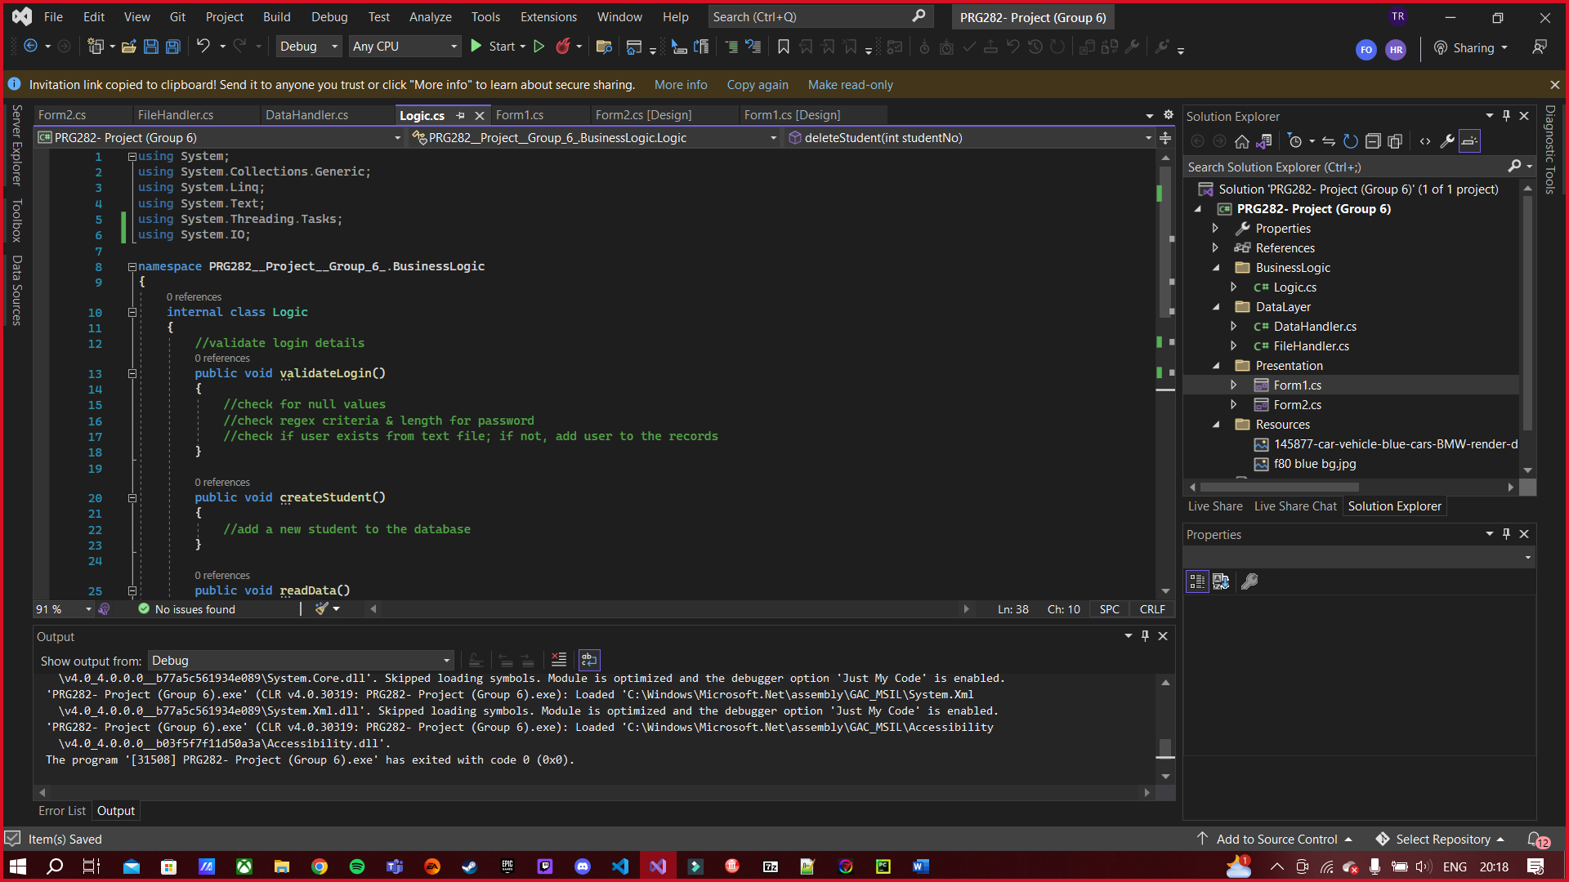The business logic layer is used to validate a user’s password when they attempt to log into the main student page. Other than validation, this layer is also used to perform CRUD operations for both the student and module tables, as instructed in the criteria of this project. Note, that the CRUD methods will be doubled due to us having two tables in the database. Here are images that show a brief design of the business logic layer with all its methods:

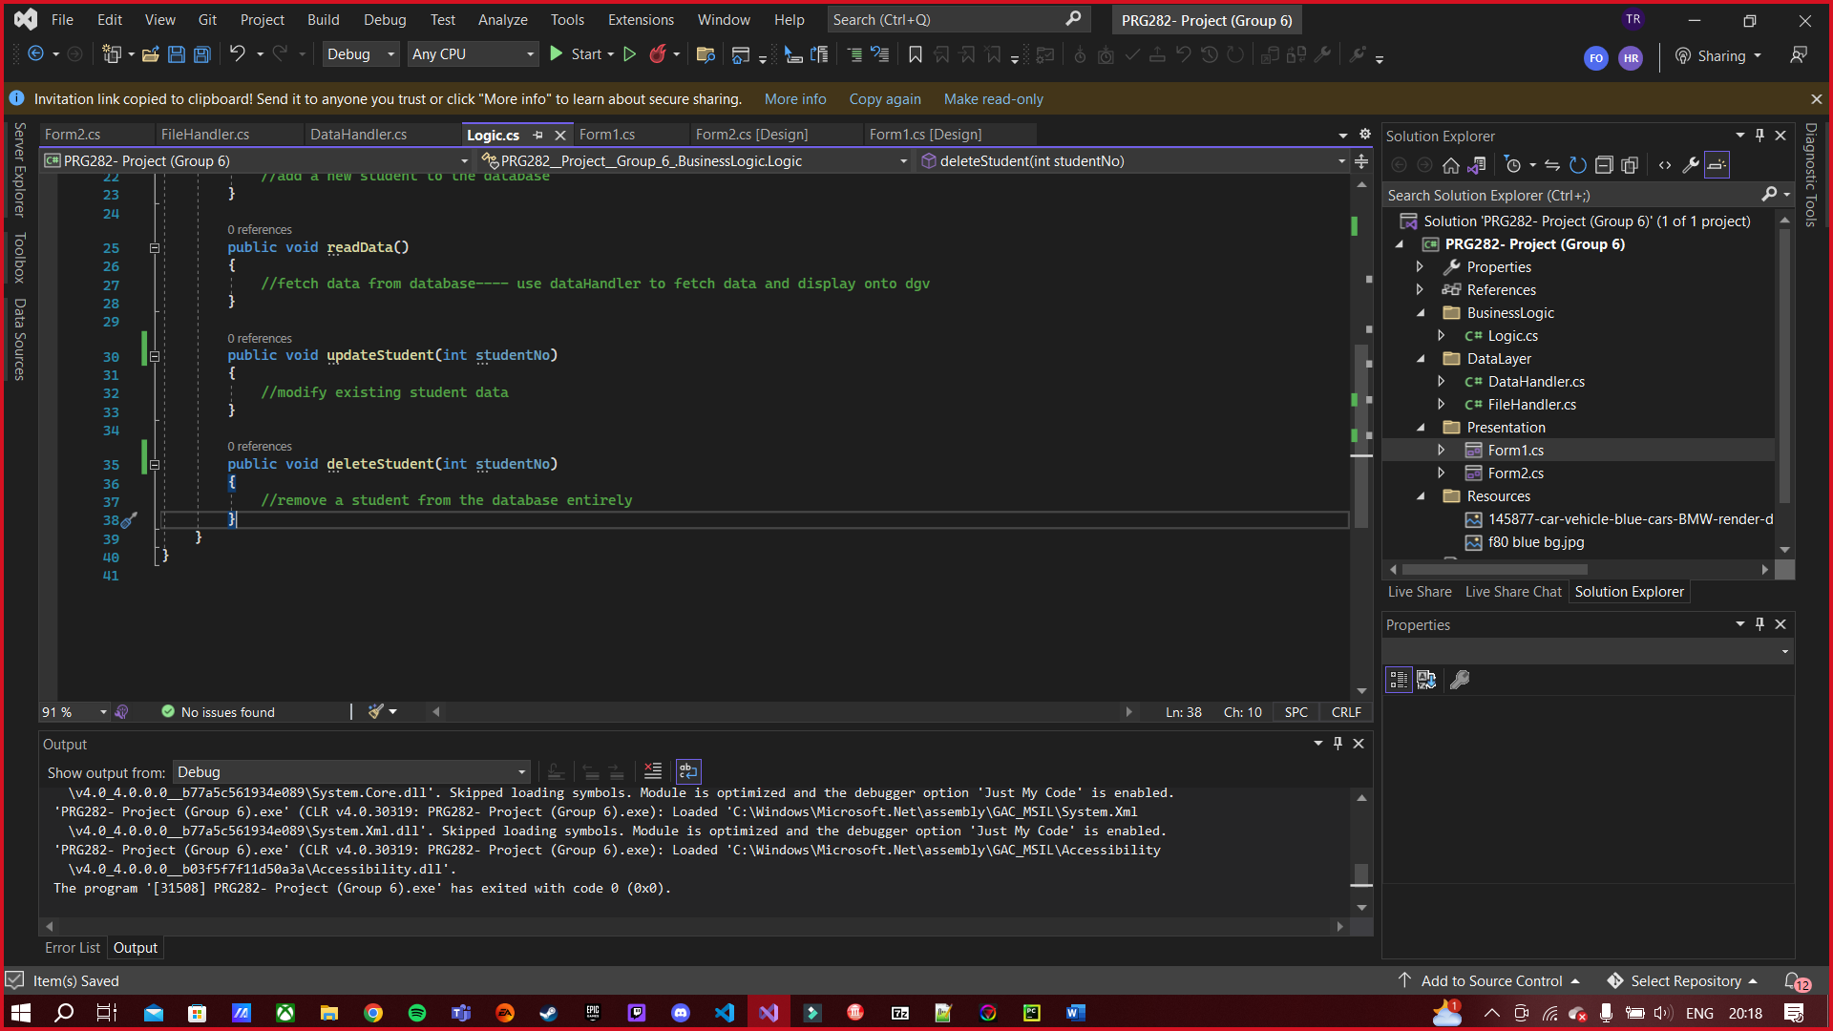

# Data Layer:

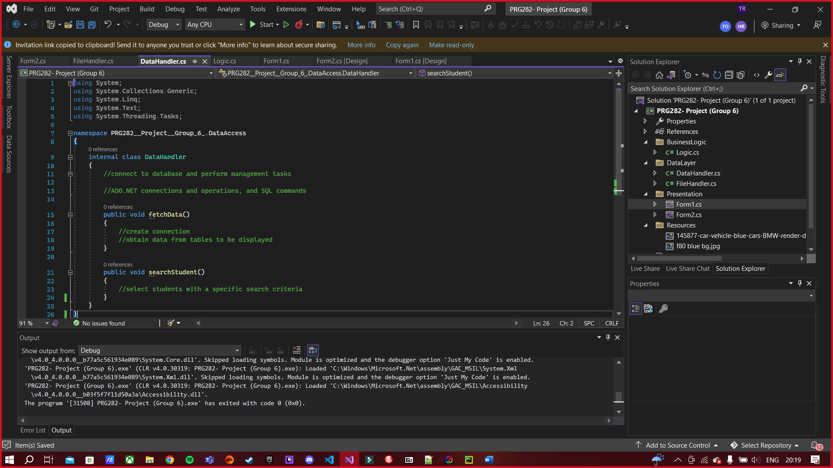The data layer will be responsible for connecting the database to the application. Once the connection is established, the data handler will execute two methods which are responsible for fetching the data from the database and displaying this onto the respective forms, as well as performing search operations with the given data. Here is a screenshot of a template of our data layer: